Name: Ken Lin

Github repository of my code : <https://github.com/DehNutCase/CSE-461/tree/master/lab4>

I believe all parts are completed successfully.

However, I don’t know how many points they are worth (the lab 4 page doesn’t say), so I assumed 20 points.

20 Points

**Report:**

Part I, Simple Remote Calculator:

Make a calculator app with the android app being the client which sends a message to the server which actually calculates the value before sending back the results.

Screenshot:

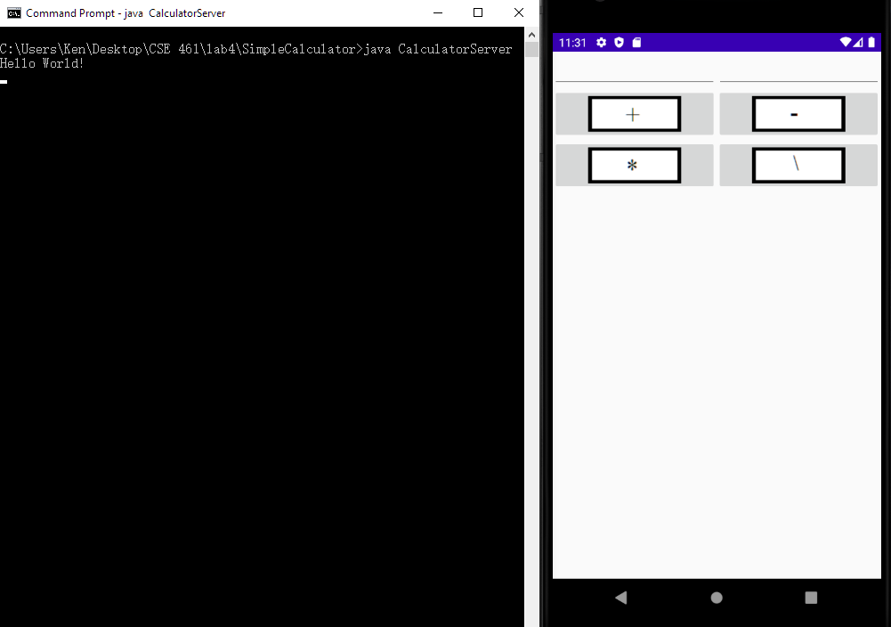

App and server started.

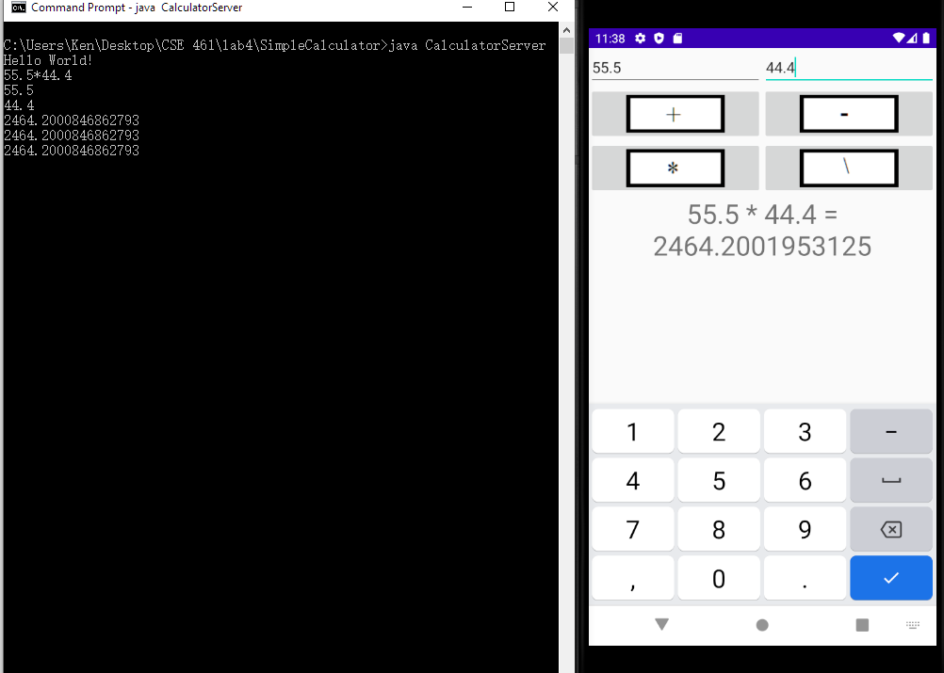

55.5 * 44.4

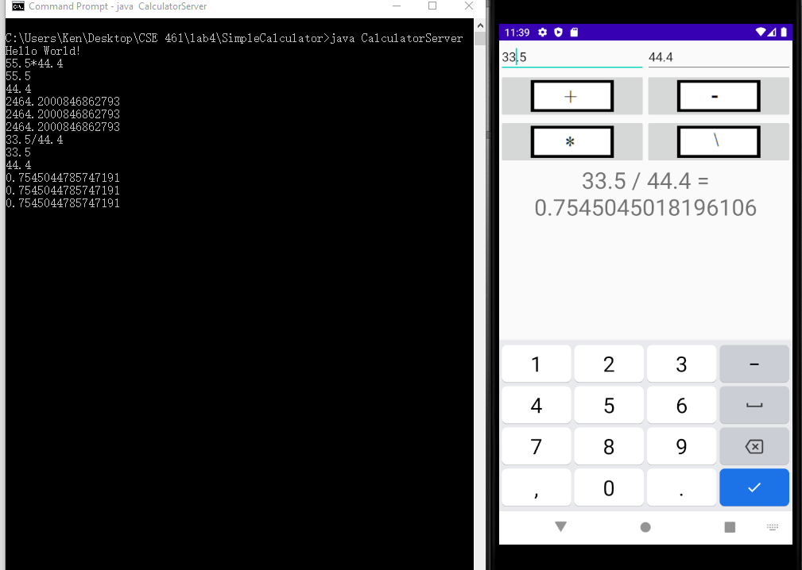

33.5 / 44.4

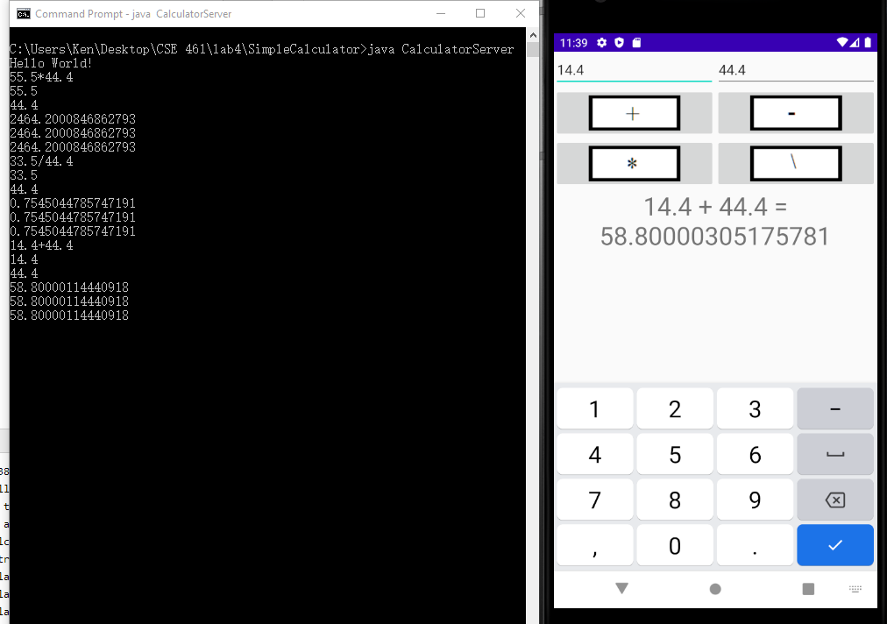

14.4 + 44.4 (trailing digits are due to rounding error from floating point.)

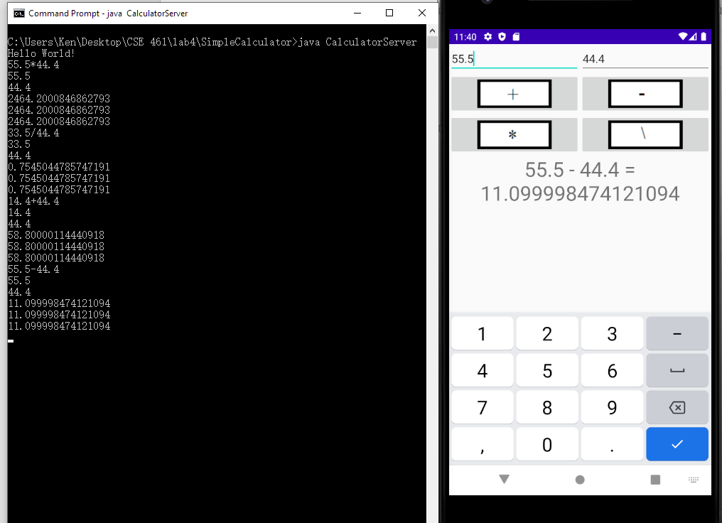

55.5 – 44.4

Code:

activity_main.xml

|  |
| --- |
| *<?***xml version="1.0" encoding="utf-8"***?>* <**LinearLayout  xmlns:android="http://schemas.android.com/apk/res/android"  android:orientation="vertical"  android:layout_width="fill_parent"  android:layout_height="fill_parent"**>  <**LinearLayout  android:layout_width="match_parent"  android:layout_height="wrap_content"  android:id="@+id/linearLayout1"  android:layout_marginLeft="12pt"  android:layout_marginRight="12pt"  android:layout_marginTop="4pt"**>  <**EditText  android:layout_weight="1"  android:layout_height="wrap_content"  android:layout_marginRight="6pt"  android:id="@+id/t1"  android:layout_width="match_parent"  android:inputType="numberDecimal"**>  </**EditText**>  <**EditText  android:layout_height="wrap_content"  android:layout_weight="1"  android:layout_marginLeft="6pt"  android:id="@+id/t2"  android:layout_width="match_parent"  android:inputType="numberDecimal"**>  </**EditText**>  </**LinearLayout**>  <**LinearLayout  android:layout_width="match_parent"  android:layout_height="wrap_content"  android:id="@+id/linearLayout2"  android:layout_marginTop="4pt"  android:layout_marginLeft="6pt"  android:layout_marginRight="6pt"**>  <**ImageButton  android:layout_height="wrap_content"  android:layout_width="match_parent"  android:layout_weight="1"  android:src="@drawable/plus_button"  android:id="@+id/plus"**>  </**ImageButton**>  <**ImageButton  android:layout_height="wrap_content"  android:layout_width="match_parent"  android:layout_weight="1"  android:src="@drawable/minux_button"  android:id="@+id/minus"**>  </**ImageButton**>  </**LinearLayout**>   <**LinearLayout  android:layout_width="match_parent"  android:layout_height="wrap_content"  android:id="@+id/linearLayout3"  android:layout_marginTop="4pt"  android:layout_marginLeft="6pt"  android:layout_marginRight="6pt"**>   <**ImageButton  android:layout_height="wrap_content"  android:layout_width="match_parent"  android:layout_weight="1"  android:src="@drawable/multiply_button"  android:id="@+id/multiply"**>  </**ImageButton**>  <**ImageButton  android:layout_height="wrap_content"  android:layout_width="match_parent"  android:layout_weight="1"  android:src="@drawable/divide_button"  android:id="@+id/divide"**>  </**ImageButton**>  </**LinearLayout**>   <**TextView  android:id="@+id/displayResult"  android:layout_width="match_parent"  android:layout_height="wrap_content"  android:layout_centerHorizontal="true"  android:layout_centerVertical="true"  android:gravity="center_horizontal"  android:textSize="32dp"**>  </**TextView**> </**LinearLayout**> |

strings.xml

|  |
| --- |
| <**resources**>  <**string name="app_name"**>Lab3SimpleCalculator</**string**> </**resources**> |

MainActivity.java (This is called lab3simplecalculator since I initialized the project by copying the lab3 code.)

|  |
| --- |
| **package** com.example.lab3simplecalculator;  **import** androidx.appcompat.app.AppCompatActivity; *//import android.support.v7.app.AppCompatActivity;* **import** android.content.Context; **import** android.os.AsyncTask; **import** android.os.Bundle; **import** android.app.Activity; **import** android.content.DialogInterface; **import** android.content.DialogInterface.OnClickListener; **import** android.os.StrictMode; **import** android.text.TextUtils; **import** android.view.Menu; **import** android.view.View; **import** android.widget.Button; **import** android.widget.ImageButton; **import** android.widget.EditText; **import** android.widget.TextView; **import** android.app.Activity; **import** android.app.ActionBar; **import** android.app.Fragment; **import** android.os.Bundle; **import** android.view.LayoutInflater; **import** android.view.Menu; **import** android.view.MenuItem; **import** android.view.View; **import** android.view.ViewGroup; **import** android.os.Build; **import** java.io.BufferedWriter; **import** java.io.IOException; **import** java.io.OutputStreamWriter; **import** java.io.PrintWriter; **import** java.net.InetAddress; **import** java.net.Socket; **import** java.net.UnknownHostException; **import** java.io.BufferedReader; **import** java.io.InputStreamReader;  **public class** MainActivity **extends** Activity **implements** View.OnClickListener{  EditText t1;  EditText t2;   ImageButton plus;  ImageButton minus;  ImageButton multiply;  ImageButton divide;   TextView **displayResult**;   String **oper** = **""**;   **private** Socket **client_socket**;  **private static final int *SERVERPORT*** = 5665; *//makesure this matches the port in CalculatorServer.java* **private static final** String ***SERVER_IP*** = **"192.168.0.100"**; *//ipconfig gets this* String **num1** = **"0"**;  String num2 = **"0"**;   */** Called when the activity is first created. */* @Override  **public void** onCreate(Bundle savedInstanceState) {  **super**.onCreate(savedInstanceState);  setContentView(R.layout.activity_main);   *// find the EditText elements (defined in res/layout/activity_main.xml* t1 = (EditText) findViewById(R.id.t1);  t2 = (EditText) findViewById(R.id.t2);   plus = (ImageButton) findViewById(R.id.plus);  minus = (ImageButton) findViewById(R.id.minus);  multiply = (ImageButton) findViewById(R.id.multiply);  divide = (ImageButton) findViewById(R.id.divide);   displayResult = (TextView) findViewById(R.id.displayResult);   *// set listeners* plus.setOnClickListener(**this**);  minus.setOnClickListener(**this**);  multiply.setOnClickListener(**this**);  divide.setOnClickListener(**this**);    **new** Thread(**new** ClientThread()).start();  }   PrintWriter out;  BufferedReader input;  **class** ClientThread **implements** Runnable {  @Override  **public void** run() {  **try** {  InetAddress serverAddr = InetAddress.getByName(SERVER_IP);  client_socket = **new** Socket(serverAddr, SERVERPORT);  out = **new** PrintWriter(**new** BufferedWriter(  **new** OutputStreamWriter(client_socket.getOutputStream())),  **true**);   input = **new** BufferedReader(**new** InputStreamReader(client_socket.getInputStream()));  } **catch** (UnknownHostException e1) {  e1.printStackTrace();  } **catch** (IOException e1) {  e1.printStackTrace();  }  }  }   *// @Override* **public void** onClick( View view ) {     *// check if the fields are empty* **if** (TextUtils.isEmpty(t1.getText().toString())  || TextUtils.isEmpty(t2.getText().toString())) {  **return**;  }   *// read EditText and fill variables with numbers* num1 = t1.getText().toString();  num2 = t2.getText().toString();   String str = **""**;   *// perform operations  // save operator in oper for later use* **switch** ( view.getId() ) {  **case** R.id.plus:  oper = **"+"**;  str = num1 + oper + num2;  **break**;  **case** R.id.minus:  oper = **"-"**;  str = num1 + oper + num2;  **break**;  **case** R.id.multiply:  oper = **"*"**;  str = num1 + oper + num2;  **break**;  **case** R.id.divide:  oper = **"/"**;  str = num1 + oper + num2;  **break**;  **default**:  **break**;  }   String[] str_list = {str};   SendfeedbackJob job = **new** SendfeedbackJob();  job.execute(str);  str = **""**;    }   **private class** SendfeedbackJob **extends** AsyncTask<String, Void, String> {  **double** result = 0;  @Override  **protected** String doInBackground(String[] params) {  **try** {  out.println(params[0]);  String inputLine = **null**;  **int** index = 0;  **while** ( ( inputLine = input.readLine() ) != **null** ) {  result = Float.parseFloat(inputLine);  index = index + 1;  **return "Done!"**;  }  } **catch** (UnknownHostException e) {  e.printStackTrace();  } **catch** (IOException e) {  e.printStackTrace();  } **catch** (Exception e) {  e.printStackTrace();  }  **return "Message sent to server and result received."**;  }   @Override  **protected void** onPostExecute(String message) {  *//process message  // form the output line* displayResult.setText(num1 + **" "** + oper + **" "** + num2 + **" = "** + result);  }  } } |

AndroidManifest.xml

|  |
| --- |
| *<?***xml version="1.0" encoding="utf-8"***?>* <**manifest xmlns:android="http://schemas.android.com/apk/res/android"  package="com.example.lab3simplecalculator"**>   <**application  android:allowBackup="true"  android:icon="@mipmap/ic_launcher"  android:label="@string/app_name"  android:roundIcon="@mipmap/ic_launcher_round"  android:supportsRtl="true"  android:usesCleartextTraffic="true"  android:theme="@style/AppTheme"**>  <**activity android:name=".MainActivity"**>  <**intent-filter**>  <**action android:name="android.intent.action.MAIN"** />   <**category android:name="android.intent.category.LAUNCHER"** />  </**intent-filter**>  </**activity**>  </**application**>    <**uses-permission android:name="android.permission.INTERNET"** />  <**uses-permission android:name="android.permission.ACCESS_NETWORK_STATE"** /> </**manifest**> |

CalculatorServer.java

|  |
| --- |
| // A simple TCP server for Demo  // @Author: T.L. Yu  import java.io.BufferedReader;  import java.io.IOException;  import java.io.InputStreamReader;  import java.net.ServerSocket;  import java.net.Socket;  import java.io.OutputStreamWriter;  import java.io.PrintWriter;  import java.io.BufferedWriter;  public class CalculatorServer {  public static void main(String[] args) throws IOException {    if (args.length != 0) {  System.err.println("Usage: java CalculatorServer");  }    int portNumber = 5665;  System.out.println("Hello World!");  try {  ServerSocket serverSocket = new ServerSocket(portNumber);  Socket clientSocket = serverSocket.accept();  BufferedReader input = new BufferedReader (  new InputStreamReader(clientSocket.getInputStream()));    String inputLine = null;  while ( ( inputLine = input.readLine() ) != null ) {  //print input line for debugging purposes  System.out.println ( inputLine );    //parse string and calculate result  String string_array[] = inputLine.split("[+\\-*/]");  System.out.println (string_array[0]);  System.out.println (string_array[1]);  double num1 = Float.parseFloat(string_array[0]);  double num2 = Float.parseFloat(string_array[1]);  String oper = "+";  int index = 0;  double result = 0;  while(true){  boolean found = false;  switch(inputLine.charAt(index)){  case '+':  result = num1 + num2;  found = true;  break;  case '-':  result = num1 - num2;  found = true;  break;  case '*':  result = num1 * num2;  found = true;  break;  case '/':  result = num1/num2;  found = true;  break;  }  if (found) break;  index = index + 1;  }  System.out.println(result);  //send result to client  PrintWriter out = new PrintWriter(clientSocket.getOutputStream(),  true);  System.out.println(result);  out.println(result);  System.out.println(result);  }  } catch (IOException e) {  System.out.println("Exception caught when trying to listen on port "  + portNumber + " or listening for a connection");  System.out.println(e.getMessage());  }  }  } |

Part II, Remote Random Number Generator:

Android client app that requests random numbers from a server.

Screenshot:

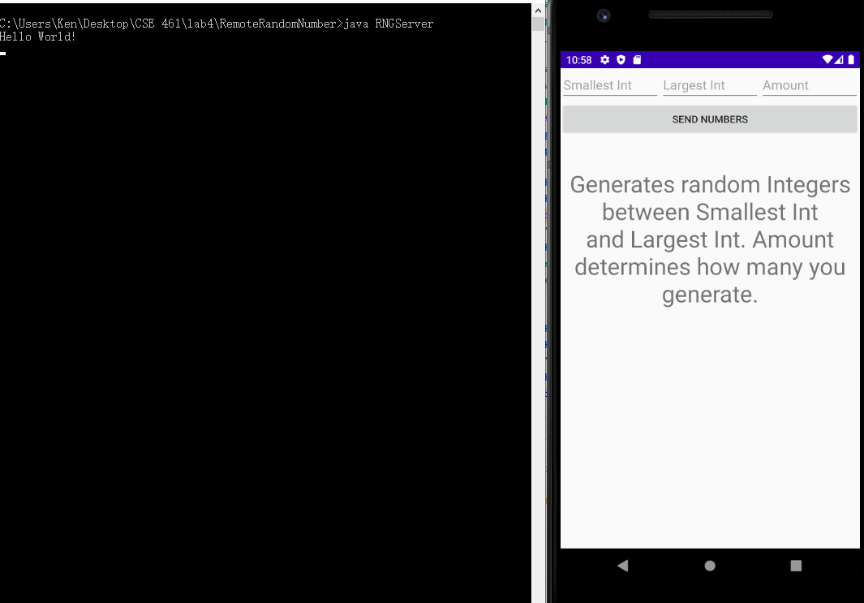

Initial start of up with server online.

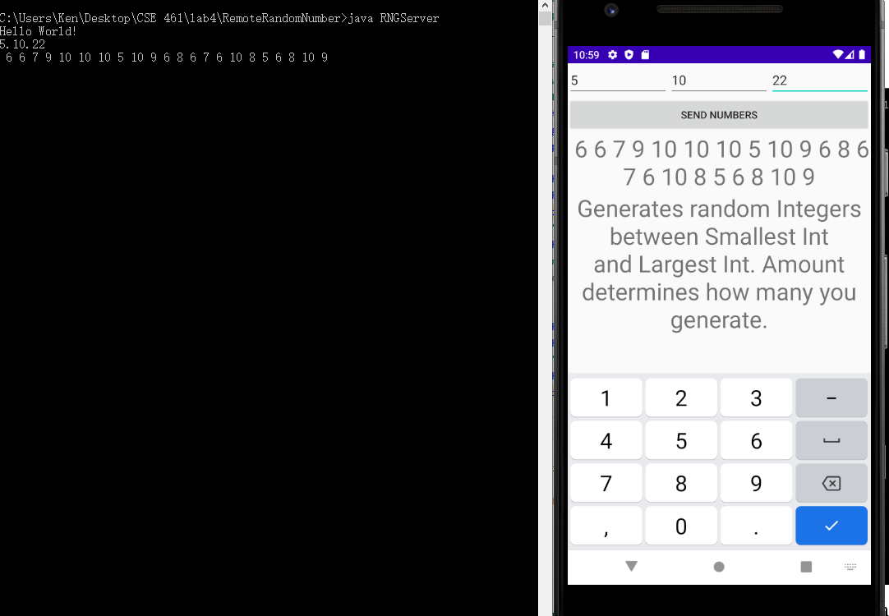

Requesting 22 numbers between 5 and 10.

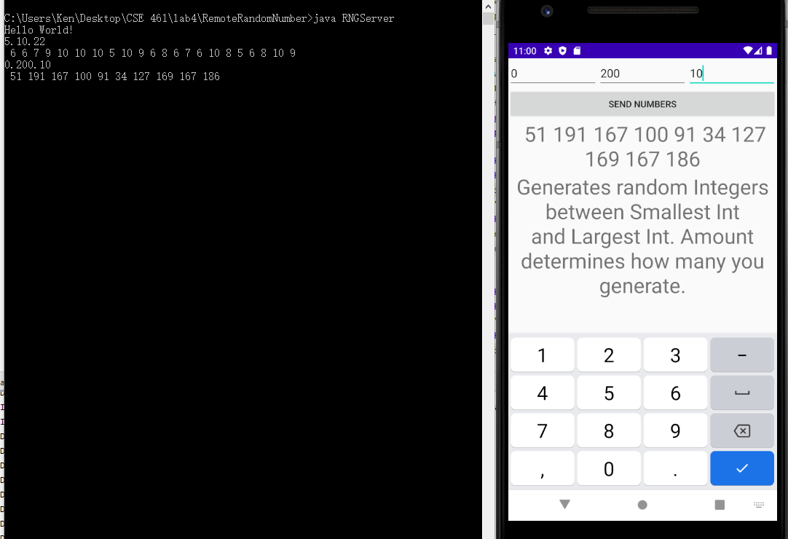

Requesting 10 numbers between 0 and 200.

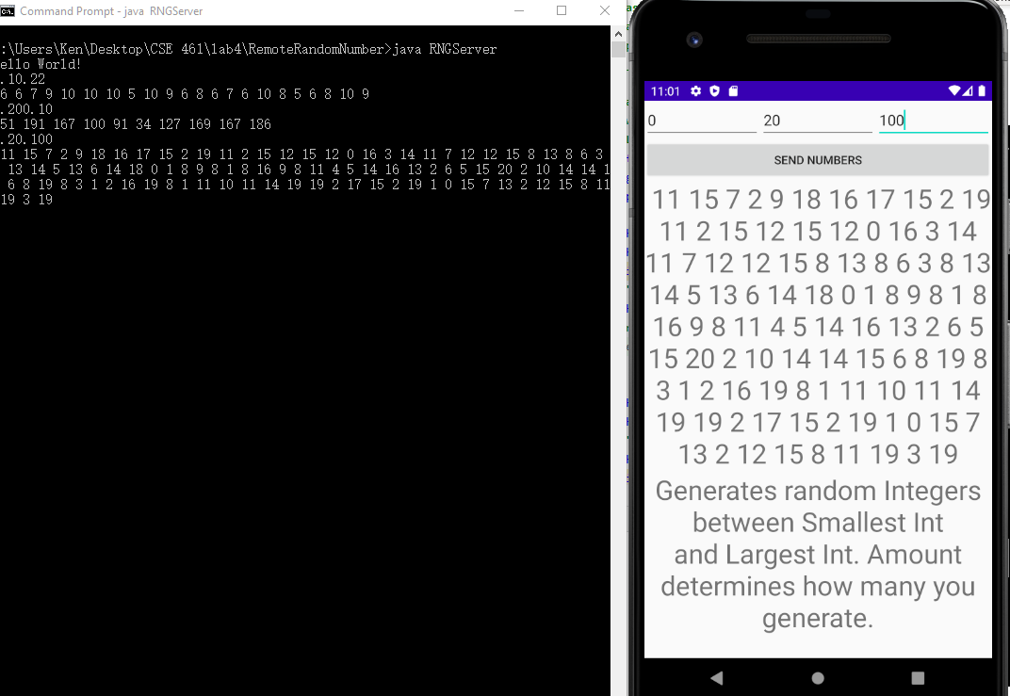

100 numbers between 0 and 20.

Code:

Activity_main.xml

|  |
| --- |
| *<?***xml version="1.0" encoding="utf-8"***?>* <**LinearLayout  xmlns:android="http://schemas.android.com/apk/res/android"  android:orientation="vertical"  android:layout_width="fill_parent"  android:layout_height="fill_parent"**>  <**LinearLayout  android:layout_width="match_parent"  android:layout_height="wrap_content"  android:id="@+id/linearLayout1"  android:layout_marginLeft="12pt"  android:layout_marginRight="12pt"  android:layout_marginTop="4pt"**>  <**EditText  android:layout_weight="1"  android:layout_height="wrap_content"  android:layout_marginRight="6pt"  android:id="@+id/t1"  android:layout_width="match_parent"  android:inputType="numberDecimal"  android:hint="@string/smallest_int"**>  </**EditText**>  <**EditText  android:layout_height="wrap_content"  android:layout_weight="1"  android:id="@+id/t2"  android:layout_width="match_parent"  android:layout_marginRight="6pt"  android:inputType="numberDecimal"  android:hint="@string/largest_int"**>  </**EditText**>  <**EditText  android:layout_weight="1"  android:layout_height="wrap_content"  android:id="@+id/t3"  android:layout_width="match_parent"  android:inputType="numberDecimal"  android:hint="@string/amount"**>  </**EditText**>  </**LinearLayout**>  <**LinearLayout  android:layout_width="match_parent"  android:layout_height="wrap_content"  android:id="@+id/linearLayout2"  android:layout_marginTop="4pt"  android:layout_marginLeft="6pt"  android:layout_marginRight="6pt"**>  <**Button  android:layout_height="wrap_content"  android:layout_width="match_parent"  android:layout_weight="1"  android:text="@string/send_numbers"  android:id="@+id/send_button"**>  </**Button**>  </**LinearLayout**>   <**TextView  android:id="@+id/displayResult"  android:layout_width="match_parent"  android:layout_height="wrap_content"  android:layout_centerHorizontal="true"  android:layout_centerVertical="true"  android:gravity="center_horizontal"  android:textSize="32dp"** >  </**TextView**>   <**LinearLayout  android:layout_width="match_parent"  android:layout_height="wrap_content"  android:id="@+id/linearLayout3"  android:layout_marginTop="4pt"  android:layout_marginLeft="6pt"  android:layout_marginRight="6pt"**>  <**TextView  android:layout_width="match_parent"  android:layout_height="wrap_content"  android:layout_centerHorizontal="true"  android:layout_centerVertical="true"  android:gravity="center_horizontal"  android:text="@string/Instruction_Text"  android:textSize="32dp"**>  </**TextView**>  </**LinearLayout**> </**LinearLayout**> |

strings.xml

|  |
| --- |
| <**resources**>  <**string name="app_name"**>Lab4RemoteRandomNumber</**string**>  <**string name="Instruction_Text"**>Generates random Integers between Smallest Int and Largest Int. Amount determines how many you generate.</**string**>  <**string name="send_numbers"**>Send Numbers</**string**>  <**string name="amount"**>Amount</**string**>  <**string name="largest_int"**>Largest Int</**string**>  <**string name="smallest_int"**>Smallest Int</**string**> </**resources**> |

MainActivity.java

|  |
| --- |
| **package** com.example.lab4remoterandomnumber;  **import** androidx.appcompat.app.AppCompatActivity;  **import** android.content.Context; **import** android.os.AsyncTask; **import** android.os.Bundle; **import** android.app.Activity; **import** android.content.DialogInterface; **import** android.content.DialogInterface.OnClickListener; **import** android.os.StrictMode; **import** android.text.TextUtils; **import** android.view.Menu; **import** android.view.View; **import** android.widget.Button; **import** android.widget.ImageButton; **import** android.widget.EditText; **import** android.widget.TextView; **import** android.app.Activity; **import** android.app.ActionBar; **import** android.app.Fragment; **import** android.os.Bundle; **import** android.view.LayoutInflater; **import** android.view.Menu; **import** android.view.MenuItem; **import** android.view.View; **import** android.view.ViewGroup; **import** android.os.Build; **import** java.io.BufferedWriter; **import** java.io.IOException; **import** java.io.OutputStreamWriter; **import** java.io.PrintWriter; **import** java.net.InetAddress; **import** java.net.Socket; **import** java.net.UnknownHostException; **import** java.io.BufferedReader; **import** java.io.InputStreamReader;  **public class** MainActivity **extends** Activity **implements** View.OnClickListener{  EditText **t1**;  EditText **t2**;  EditText **t3**;   Button **send**;   TextView **displayResult**;   String **oper** = **""**;   **private** Socket **client_socket**;  **private static final int *SERVERPORT*** = 6556; *//makesure this matches the port in RNGServer.java* **private static final** String ***SERVER_IP*** = **"192.168.0.100"**; *//ipconfig gets this* String **num1** = **"0"**;  String **num2** = **"0"**;  String **num3** = **"1"**;   */** Called when the activity is first created. */* @Override  **public void** onCreate(Bundle savedInstanceState) {  **super**.onCreate(savedInstanceState);  setContentView(R.layout.***activity_main***);   *// find the EditText elements (defined in res/layout/activity_main.xml* **t1** = (EditText) findViewById(R.id.***t1***);  **t2** = (EditText) findViewById(R.id.***t2***);  **t3** = (EditText) findViewById(R.id.***t3***);   **send** = (Button) findViewById(R.id.***send_button***);   **displayResult** = (TextView) findViewById(R.id.***displayResult***);   *// set listeners* **send**.setOnClickListener(**this**);   **new** Thread(**new** ClientThread()).start();  }   PrintWriter **out**;  BufferedReader **input**;  **class** ClientThread **implements** Runnable {  @Override  **public void** run() {  **try** {  InetAddress serverAddr = InetAddress.*getByName*(***SERVER_IP***);  **client_socket** = **new** Socket(serverAddr, ***SERVERPORT***);  **out** = **new** PrintWriter(**new** BufferedWriter(  **new** OutputStreamWriter(**client_socket**.getOutputStream())),  **true**);   **input** = **new** BufferedReader(**new** InputStreamReader(**client_socket**.getInputStream()));  } **catch** (UnknownHostException e1) {  e1.printStackTrace();  } **catch** (IOException e1) {  e1.printStackTrace();  }  }  }   *// @Override* **public void** onClick( View view ) {   *// check if the fields are empty* **if** (TextUtils.*isEmpty*(**t1**.getText().toString())  || TextUtils.*isEmpty*(**t2**.getText().toString())  || TextUtils.*isEmpty*(**t3**.getText().toString())) {  **return**;  }   *// read EditText and fill variables with numbers* **num1** = Integer.*toString*(Integer.*parseInt*(**t1**.getText().toString())); *//forcibly checks that num 1 is an int rather than a float* **num2** = Integer.*toString*(Integer.*parseInt*(**t2**.getText().toString()));  **num3** = Integer.*toString*(Integer.*parseInt*(**t3**.getText().toString()));   String str = **num1** + **"."** + **num2** + **"."** + **num3**;   SendfeedbackJob job = **new** SendfeedbackJob();  job.execute(str);  str = **""**;  }   **private class** SendfeedbackJob **extends** AsyncTask<String, Void, String> {  String **result** = **""**;  @Override  **protected** String doInBackground(String[] params) {  **try** {  **out**.println(params[0]);  String inputLine = **null**;  **int** index = 0;  **while** ( ( inputLine = **input**.readLine() ) != **null** ) {  **result** = inputLine;  index = index + 1;  **return "Done!"**; *//doesn't work without this line, I don't think I'm using Asynch Task properly* }  } **catch** (UnknownHostException e) {  e.printStackTrace();  } **catch** (IOException e) {  e.printStackTrace();  } **catch** (Exception e) {  e.printStackTrace();  }  **return "Message sent to server and result received."**;  }   @Override  **protected void** onPostExecute(String message) {  *//process message  // form the output line* **displayResult**.setText(**result**);  }  } } |

AndroidManifest.xml

|  |
| --- |
| *<?***xml version="1.0" encoding="utf-8"***?>* <**manifest xmlns:android="http://schemas.android.com/apk/res/android"  package="com.example.lab4remoterandomnumber"**>   <**application  android:allowBackup="true"  android:icon="@mipmap/ic_launcher"  android:label="@string/app_name"  android:roundIcon="@mipmap/ic_launcher_round"  android:supportsRtl="true"  android:usesCleartextTraffic="true"  android:theme="@style/AppTheme"**>  <**activity android:name=".MainActivity"**>  <**intent-filter**>  <**action android:name="android.intent.action.MAIN"** />   <**category android:name="android.intent.category.LAUNCHER"** />  </**intent-filter**>  </**activity**>  </**application**>   <**uses-permission android:name="android.permission.INTERNET"** />  <**uses-permission android:name="android.permission.ACCESS_NETWORK_STATE"** /> </**manifest**> |

RNGServer.java (I kept the comments from the sample server file I got from Dr. Yu)

|  |
| --- |
| // A simple TCP server for Demo  // @Author: T.L. Yu  import java.io.BufferedReader;  import java.io.IOException;  import java.io.InputStreamReader;  import java.net.ServerSocket;  import java.net.Socket;  import java.io.OutputStreamWriter;  import java.io.PrintWriter;  import java.io.BufferedWriter;  import java.util.Random;  public class RNGServer {  public static void main(String[] args) throws IOException {    if (args.length != 0) {  System.err.println("Usage: java RNGServer");  }    int portNumber = 6556;  System.out.println("Hello World!");  try {  ServerSocket serverSocket = new ServerSocket(portNumber);  Socket clientSocket = serverSocket.accept();  BufferedReader input = new BufferedReader (  new InputStreamReader(clientSocket.getInputStream()));    String inputLine = null;  while ( ( inputLine = input.readLine() ) != null ) {  //print input line for debugging purposes  System.out.println ( inputLine );    //parse string and calculate result  String string_array[] = inputLine.split("\\D");  int num1 = Integer.parseInt(string_array[0]);  int num2 = Integer.parseInt(string_array[1]);  int num3 = Integer.parseInt(string_array[2]);    int index = 0;  String result = "";  StringBuilder result_builder = new StringBuilder();    if(num2 < num1){  //make sure num1 is <= num2  int temp = num1;  num1 = num2;  num2 = temp;  }    Random rand = new Random();    while (index < num3){  index = index + 1;    //generates a random integer between num1 and num2  int new_random = rand.nextInt(num2 - num1 + 1);  new_random = new_random + num1;    if (index != 0){  result_builder.append(" "); //make sure numbers are separated by space  }  result_builder.append(new_random); //add number to string  }    result = result_builder.toString();    //send result to client  PrintWriter out = new PrintWriter(clientSocket.getOutputStream(),  true);  out.println(result);  System.out.println(result); //printing result to be sure it worked  }  } catch (IOException e) {  System.out.println("Exception caught when trying to listen on port "  + portNumber + " or listening for a connection");  System.out.println(e.getMessage());  }  }  } |